**Linear Regression on Boston Housing Dataset**

Regression involves using one or more variables, labelled independent variables, to predict the values of another variable, the dependent variable. Variables that are strongly correlated with the dependent variable will be used for predicting that variable.

We will take the Housing dataset which contains information about different house Boston. We can also access this data from the scikit-learn library. There are 506 samples and 13 feature variables in this dataset. The objective is to predict the value of prices of the house using the given features.

We print the value of the boston_dataset to understand what it contains.

* Data: contains the information for various houses
* Target: prices of the house
* Feature_names: names of the features
* DESCR: describes the dataset

To know more about the features use boston_dataset.DESCR The description of all the features is given below:

**CRIM**:Per capita crime rate by town  
**ZN**: Proportion of residential land zoned for lots over 25,000 sq. ft  
**INDUS**:Proportion of non-retail business acres per town  
**CHAS**: Charles River dummy variable (= 1 if tract bounds river; 0 otherwise)  
**NOX**: Nitric oxide concentration (parts per 10 million)  
**RM**: Average number of rooms per dwelling  
**AGE**: Proportion of owner-occupied units built prior to 1940  
**DIS**: Weighted distances to five Boston employment centers  
**RAD**: Index of accessibility to radial highways  
**TAX**: Full-value property tax rate per $10,000  
**PTRATIO**: Pupil-teacher ratio by town  
**B**: 1000(Bk — 0.63)², where Bk is the proportion of [people of African American descent] by town  
**LSTAT**: Percentage of lower status of the population  
**MEDV**: Median value of owner-occupied homes in $1000s

The prices of the house indicated by the variable MEDV is our target variableand the remaining are the feature variables based on which we will predict the value of a house.

We will now load the data into a pandas

### Exploratory Data Analysis

**Describe**

**Pandas describe**()

Pandas describe() is used to view some basic statistical details like percentile, mean, std etc. of a data frame or a series of numeric values. When this method is applied to a series of string,

it returns a different output.

# 

# Dataframe.info()

# Pandas**dataframe.info()** function is used to get a concise summary of the dataframe. It comes really handy when doing exploratory analysis of the data. To get a quick overview of the dataset we use the dataframe.info() function.

# 

# ****Exploratory Data Analysis****

Exploratory Data Analysis is a very important step before training the model. In this section, we will use some visualization to understand the relationship of the target variable with other features.

# We will use the distplot function from the seaborn library. Flexibly plot a univariate distribution of observations.

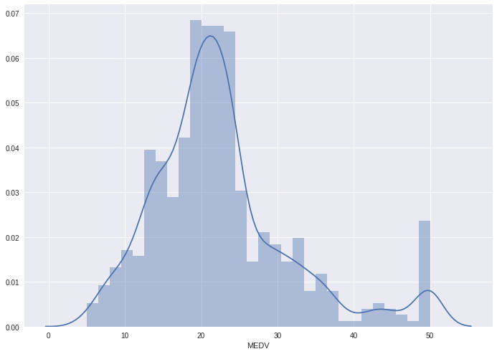

We see that the values of MEDV are distributed normally with few outliers.

Next, we create a correlation matrix that measures the linear relationships between the variables. The correlation matrix can be formed by using the corr function from the pandas dataframe library. We will use the heatmapfunction from the seaborn library to plot the correlation matrix.

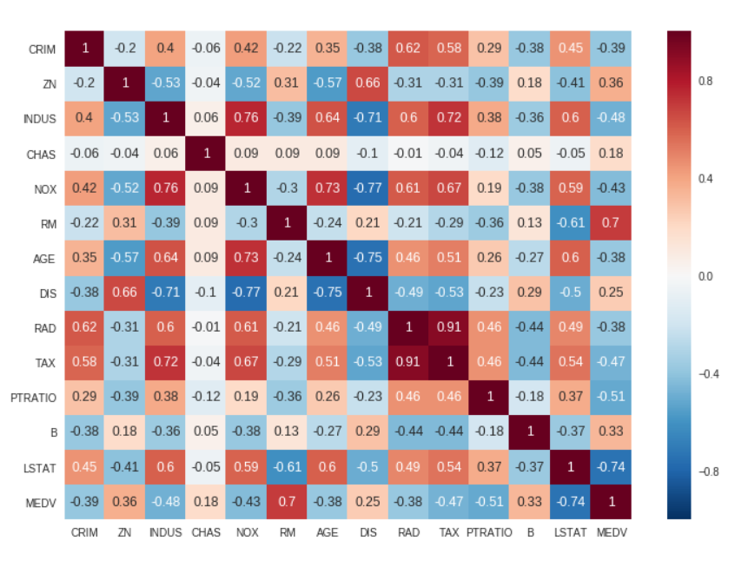

The correlation coefficient ranges from -1 to 1. If the value is close to 1, it means that there is a strong positive correlation between the two variables. When it is close to -1, the variables have a strong negative correlation.

# ****Observations:****

* To fit a linear regression model, we select those features which have a high correlation with our target variable MEDV. By looking at the correlation matrix we can see that RM has a strong positive correlation with MEDV (0.7) where as LSTAT has a high negative correlation with MEDV(-0.74).
* An important point in selecting features for a linear regression model is to check for multi-co-linearity. The features RAD, TAX have a correlation of 0.91. These feature pairs are strongly correlated to each other. We should not select both these features together for training the model. Check this for an explanation. Same goes for the features DIS and AGEwhich have a correlation of -0.75.

Based on the above observations we will RM and LSTAT as our features.

Using a scatter plot let’s see how these features vary with MEDV.

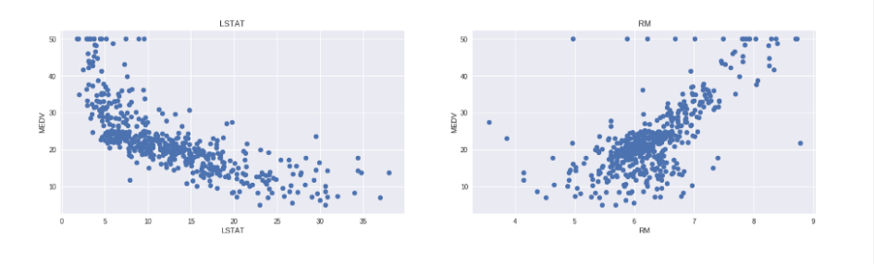

# ****Observations:****

* The prices increase as the value of RM increases linearly. There are few outliers and the data seems to be capped at 50.
* The prices tend to decrease with an increase in LSTAT. Though it doesn’t look to be following exactly a linear line.

# **Preparing the data for training the model**

# We concatenate the LSTAT and RM columns using np.c_ provided by the numpy library.

# **Splitting the data into training and testing sets**

Next, we split the data into training and testing sets. We train the model with 80% of the samples and test with the remaining 20%. We do this to assess the model’s performance on unseen data. To split the data we use train_test_split function provided by scikit-learn library. We finally print the sizes of our training and test set to verify if the splitting has occurred properly.

# ****Training and testing the model****

We use scikit-learn’s LinearRegression to train our model on both the training and test sets.

We will evaluate our model using RMSE and R2-score.

The model performance for training set   
--------------------------------------   
RMSE is 5.6371293350711955   
R2 score is 0.6300745149331701 The model performance for testing set   
--------------------------------------   
RMSE is 5.137400784702911  
R2 score is 0.6628996975186952

# ****Conclusion****

In this program, we applied the concepts of linear regression on the Boston housing dataset.